PCI DSS Compliance in a State-Wide Clothing Chain
Trevor M. Pelfrey
Western Governors University

Table of Contents
Summary 3
Review of Other Work 6
Changes to the Project Environment 9
Methodology 10
Project Goals and Objectives 12
Project Timeline 14
Unanticipated Scope Creep 16
Conclusion 17
References 19
Appendix A 20
Appendix B 21
Appendix C 22

Summary
Johann and Sons is a growing clothing company in California. The company comprises 26,000 employees, all of whom work within the state, with orders from all over the North American continent. Johann and Sons has recently begun to process enough transactions a year, and it has moved into Payment Card Industry Data Security Standard (PCI DSS) level 1. PCI DSS Level 1 requires that a corporation complete a Report of Compliance (ROC), an Approved Scanning Vendor (ASV) Scan, and an Attestation of Compliance (AOC). Due to a combination of security incidents and compliance requirements, it was necessary to assess to ensure that the network was compliant.
When assessed by a PCI DSS compliance consultant, the model store was found non-compliant with the PCI DSS standard. Store wi-fi devices were using the deprecated WEP standard for securing the payment card data environment, making it vulnerable to anybody with the knowledge to exploit the weakness. Using WEP would result in the penetration of the network and dropping several entries in the store stock database. The network was not segmented, meaning any device could intercept payment card data. A limited number of IT staff would result in duties such as reading logs being left incomplete.
Johann and Sons' leadership took immediate action to rectify this issue, as non-compliance with PCI DSS can result in significant fines and potential loss of the ability to process card payments. The CTO hired an MSP specializing in PCI DSS compliance to design and maintain the store's network environments. The MSP team implemented a form of Agile methodology called Kanban, which allows easy visualization and tracking of work. They used Asana to generate digital Kanban boards, which had four stages of work: to-do, in-progress, validation, and done. They wrote cards with specific issues, details on the issue, the nature of the issue, and the due date. The cards were placed in the to-do stage until somebody is assigned to it. The card is placed in the in-progress stage when somebody is assigned to the issue. Once work is done, it is placed in the validation stage, and if it passes validation, it will be moved to the done stage. The MSP team would implement Kanban through Asana, tracking the cards across all four stages. During the period of the project, the MSP team would install WPA 3 devices to replace the outdated WEP default devices and segment the network with new switches. Post-project timelines, they would be kept on to monitor logs and provide technical support with the network. The resulting artifacts from this engagement with the MSP team were a pre-implementation network diagram, a post-implementation network diagram, and a network segmentation table used with the new switches installed in the network.
After the execution of the project, the network was found compliant with PCI DSS by a qualified security assessor. Store security posture would be improved considerably and because the store is being used as a model for all other company stores, changes to meet compliance will occur there as well. The MSP would remove WEP usage from the network, replace end-of-life devices, properly configure misconfigured devices, implement a new network diagram, and implement network segmentation, all of which would be handled over the course of a month by the MSP team. The addition of the MSP team would also rectify the staffing issue, allowing IT staff to focus on hardware side issues while the MSP team focuses on software side issues.
During implementation, problems with employee security consciousness would be noticed at other locations, resulting in a review of the security training material for non-IT personnel. Through a combination of research and suggestions from internal IT and the MSP team, the CTO would compose a training plan that was not just one lecture but a series of interactive videos and exercises that would take place throughout the year. The CTO believes this change in approach will improve employees' security consciousness and posture.
After hiring more IT personnel, it would be determined that the current runbooks and playbooks were outdated. The CISO would be tasked to perform research and consult internal security personnel to determine how to modernize. The CISO would use the model store as an example to build the playbooks and runbooks, setting five main criteria for their creation: Identify company assets, outline potential threats, document response plans, integrate with incident management tools, and update and refine regularly. Under those criteria, new runbooks and playbooks would be made and distributed to the IT security staff.

Review of Other Work
MSP vs. Internal IT Team: One of the problems that the CTO encountered while considering securing people to work on the store network was that they had never had to decide on internal versus external contracting before. They did not know the pros and cons of each implementation and how it might be appropriate for the company. The CTO used this article to decide how to approach the IT staffing shortage issue. In "MSP vs. Internal IT Team," Anthony Hernandez writes about the pros and cons of using an MSP versus an Internal IT Team. For this project, the most important aspect was the section on how an MSP and Internal IT Team may work together in a hybrid model. The specific use case mentioned that is relevant to this scenario is of a business with a small IT team that cannot perform all of its tasks. In that situation, "MSPs assist with patch management, disaster recovery, and help desk support, reducing the workload on a small internal IT team."(Captain IT, n.d.). Considering that Johann and Sons' IT personnel were stretched thin between stores with minimal ability to keep networks up to standard, this approach will be helpful for present needs and provide room for IT team expansion in the future.

How to create an incident response playbook: After hiring more qualified IT personnel, it was found that the playbooks and runbooks mentioned in the previous report were not up to date, having been written around the time Johann and Sons were established. Many people writing the runbook and playbook are no longer working at Johann and Sons, so it falls upon the CISO and other qualified personnel to update or write new ones. The CISO would utilize this blog post alongside others to determine how best to set up templates for the most common situations. Subrosa set out five main criteria for the creation of an efficient runbook. These include identifying company assets, outlining potential threats, documenting response plans, integrating with incident management tools, and updating and refining regularly. Regular refinement and updating was one of the more significant issues Johann and Sons ran into while maintaining their cybersecurity and compliance posture, so this deserves extra focus. On the topic of regular updates and refinement, SubRosa states, "Your security runbook template is not a one-off document that you can just set and forget. It needs to be a living, evolving document that changes as your business and the threat landscape change. Regularly review and refine your runbook to ensure it remains relevant and efficient." (SubRosa Cyber, n.d.)
Developing a Security Mindset: Training Techniques for Non-Technical Staff: When the model store was assessed for PCI DSS compliance, more significant inquiry into the security posture of some of the other stores was warranted. Some stores had sticky notes with passwords on various appliances, unlocked management devices left unattended, and other security policy violations. The worst of these stores had previously had a data breach left unattended. The consensus was that the current security training was insufficient. The current training method is a series of lectures, which is impractical for getting employees to engage with and remember the training. Brandefense recommends a more gamified approach: "Security training should move beyond traditional lecture-based formats and incorporate interactive elements to engage non-technical staff effectively. This can include gamified learning experiences, hands-on workshops, and simulation exercises that mimic real-life scenarios. Such approaches help reinforce learning and make the training process more engaging and memorable." (Brandefense, 2024). ​

Changes to the Project Environment
After the changes to the model store network were made, two things were determined: that there were not enough staff to maintain store networks and that store security training for non-IT personnel was lacking. The solution for the lack of qualified staff was a contract with an MSP and hiring more IT personnel. The solution for security training elaborates on what was mentioned in "Developing a Security Mindset: Training Techniques for Non-Technical Staff." The initial training material encompassed a series of lectures with little follow-up or interactivity. Employees may have little personal interest in maintaining cybersecurity, so use examples that may be relevant to them and their lives. Suppose they fear getting their bank credentials stolen or their accounts phished. In that case, they may be more likely to remember the training, as they want to maintain their security. Interactivity during lectures and security drills should also be implemented. During a lecture, the lecturer could ask questions about the security of the staff, and those who answer the questions correctly could get something small like a five or ten-dollar gift card to a coffee shop. The addition of a reward and interactivity will increase memory retention. The addition of cybersecurity drills, such as phishing simulations, can act as a learning opportunity for those who open them, allowing security staff to counsel them on how to avoid phishing emails in the future. The most important part of improving the security posture of Johann and Sons is to create an environment where there is no blame. Employees are more likely to say something about security issues if they are not likely to receive reprisals.

Methodology
While working on the model store network, the MSP team used Kanban to prioritize and keep track of issues with the network. Kanban is an Agile framework that focuses on continuous improvement, flexibility, and focus on self-organizing teams. The lifecycle of an issue in the Kanban methodology goes from to-do to in-progress, to validation to finished. The traditional way of using the Kanban methodology is to have an established board with all of the cards starting in the to-do stage. However, modern iterations of Kanban use digital boards such as Jira or Asana to track the issue lifecycle.
First, the Kanban card is written with a brief description of the issue, due dates, functionalities, and the nature of the task. This card is placed in the to-do stage, where it stays until team members are assigned to it. Once team members are assigned to the card, it is moved to the in-progress stage. Once the issue on the card is completed, it is sent to the validation stage, where the solution is tested to ensure it is fit for purpose. The card is placed in the done stage if it fits the purpose. Because Agile focuses on continuous development, steps repeat until the project is done.
During the planning phase, the CISO, IT security staff, and MSP team would meet to discuss the company's needs. The staff present would outline the need for assistance with conforming to the PCI DSS requirements and increasing security posture. These goals would be cut down into issues that one or more people would more easily do.
During the design phase, a network diagram of the current model store network and security-focused redesign will be made. In this stage, network segmentation would be planned to limit the size of the payment card data environment, resulting in a table of networks that connect based on the principle of least privilege or "need to connect."
The testing phase would ensure that the developed network solution would work as it should. A test lab would be built in the MSP office utilizing the same equipment as the solution. Tests would be done to ensure that certain network segments couldn't speak to others and ensure that outbound firewall rules function.
In the deployment phase, appliances would be installed at the model store, or configuration changes would be pushed to the appropriate devices. The WEP WAPs would be replaced with WPA3 capable WAPs, Layer 3 switches would be installed and configured, and further cable runs would be made to support the expansion of the network.
In the review phase, the model store IT specialist, the security team, and the MSP will meet to determine the current functionality of the network. Where shortcomings exist, the team will add issues to the Kanban board and renew the cycle starting again from the design phase.

Project Goals and Objectives
 | Goal | Supporting Objectives | Objective Met/Unmet | Goal Met/Unmet
1 | Understand the current network | 1. a: Build a topology of the current network | MET | MET
 |  | 1.b: Gather hardware, software, and service information | MET
2 | Assess the PCI DSS compliance of the current network | 2. a: Compare the network environment against the PCI DSS requirements | MET | MET
 |  | 2.b: Determine the key problems causing lack of compliance | MET
3 | Provide a solution to restore PCI DSS compliance | 3. a: Onboard an MSP to perform maintenance and compliance procedures on the network | MET | MET
 |  | 3.b: Build a network diagram with segmentation in mind | MET
 |  | 3.c: (optional) Onboard IT personnel to eventually take over for the MSP | UNMET

Johann and Sons set out to achieve three goals when this project started. The goals were to understand the network, Assess the PCI DSS compliance of the network, and, assuming that the network was non-compliant, find a solution to restore PCI DSS compliance. The solution to restoring PCI DSS compliance was to onboard an MSP, build a network diagram with segmentation in mind, and onboard IT personnel to participate in a hybrid internal IT and MSP model.
After briefing the MSP on the compliance issues suffered by Johann and Sons, they would design and implement a network design that fit the needs of Johann and Sons. This mainly replaced the old TP-Link TL-WA701ND WAPs with WPA3 capable devices, in this case, Cisco Catalyst 9100s. The next problem they would resolve would be the lack of network segmentation. Two-layer 3 switches would be used to segment the network based on functionality. Please refer to Appendix C for the table used for the configuration. Adding an SIEM and IPS to the store would also improve security posture and PCI DSS compliance with requirements involving logs. When Johann and Sons hired a penetration testing company to do a full test on the model store, the only issue found was unintended camera access, to which the cameras would be configured more securely. Johann and Sons would then have another PCI DSS compliance audit done successfully. There was one objective that was deprioritized during the period of this project. This was because of the choice to change from an Internal IT-focused approach to a hybrid MSP and Internal IT model, where both support each other for a greater security posture and PCI DSS compliance.

Project Timeline

Milestone | Duration  (hours or days) | Projected Start Date | Anticipated End Date | Actual Start | Actual End
Assemble the current network diagram | 4 hours | 3/3/2025 | 3/3/2025 | 3/3/2025 | 3/3/2025
Gather network hardware, software, and service information | 3 days | 3/4/2025 | 3/7/2025 | 3/4/2025 | 3/7/2025
Compare the network environment against the PCI DSS requirements | 7 days | 3/7/2025 | 3/14/2025 | 3/7/2025 | 3/14/2025
Determine the key problems causing the lack of compliance | 4 hours | 3/14/2025 | 3/14/2025 | 3/14/2025 | 3/14/2025
Research and shortlist MSPs Specializing in PCI DSS compliance | 14 days | 3/14/2025 | 3/28/2025 | 3/14/2025 | 3/28/2025
Onboard an MSP to perform maintenance and compliance procedures on the network | 14 days | 2/28/2025 | 3/14/2025 | 2/28/2025 | 3/21/2025
Build a network diagram with segmentation in mind | 3 days | 3/14/2025 | 3/17/2025 | 3/21/2025 | 3/24/2025
Staff Onboarding and Training | 90 days | 3/3/2025 | 06/01/2025 | 3/3/2025 | 06/01/2025

In the execution of this project, difficulties with maintaining timelines were observed. The proposed period for hiring and onboarding the MSP was from March 17th, 2025, to April 1st, 2025, but this would end on April 15th, 2025 instead. This would be caused by Johann and Sons' inexperience in finding, onboarding, and working with MSPs. This would also set back any milestones that relied upon this step by fourteen days, affecting the network redesign and installation. The milestones for the project would all be completed except for one that was changed during project development. After determining that a hybrid MSP and internal staff model would be best for Johann and Sons, the prioritization of hiring new personnel was reduced in favor of increasing MSP responsibilities.

Unanticipated Scope Creep
The initial goals were to achieve PCI DSS compliance and an increased security posture; however, the latter of these goals would expand further than expected into organizational change and more extensive network diagrams. Initially, the playbooks, runbooks, and security training material would have been sufficient for Johann and Son's purpose due to the lack of problems related to the material in the model store. However, these elements were wanting. The original network for the model store had been simple. However, to comply with the PCI DSS, it had to be expanded with the addition of network segmentation technologies and intrusion detection. To further future-proof, centralized security solutions were used to have a SOC monitor log and perform remote service for all locations. However, this was replaced with a hybrid internal staff and MSP model.

Conclusion
Two goals for success in this project are compliance with PCI DSS and improvement of overall security posture. Improvement of security posture includes three sub-goals: Eliminating WEP from the network, replacing end-of-life equipment, and securing misconfigured systems. All of these goals would be met through the combined efforts of the MSP team and internal IT. Research and contracting for the MSP took longer than expected due to company inexperience with contracting MSPs, resulting in a fourteen-day milestone being reached in twenty-one. This would push back any milestones and goals that relied upon the MSP team by an additional week.
The MSP team replaced end-of-life equipment and configured misconfigured devices under industry standards. It ensured that WEP was no longer used on the model store network, utilizing the PCI DSS violation table as a reference for the problems that existed on the network. A penetration test would be undertaken against the network, focusing on PCI DSS compliance. Threats against the network were minimal, and penetration testers could not reach the payment card data environment. A qualified security assessor would be hired to assess if the model store network was compliant. The qualified security assessor would find the model store network compliant with PCI DSS. The changes would reduce future breach risks across Johann and Sons store networks, payment card data environments, and support long-term compliance with considerations made for expansion.
While the project goals were met and considered a success, problems were discovered during execution. Outside of the model store, security consciousness was lacking. Security runbooks and playbooks would be determined to be outdated compared to the current threat environment. Both of these would be added on as sub-goals under improvement of security posture, resulting in scope creep.

References
Captain IT. (n.d.). MSP vs. internal IT team: Which is right for your business? Captain IT. https://captainit.com/msp-vs-internal-it-team/
SubRosa Cyber. (n.d.). Creating an efficient security runbook template: A comprehensive guide to cybersecurity excellence. SubRosa Cyber. https://www.subrosacyber.com/en/blog/security-runbook-template
Brandefense. (2024, June 13th). Developing a security mindset: Training techniques for non-technical staff. Brandefense Blog. https://brandefense.io/blog/developing-a-security-mindset-training-techniques-for-non-technical-staff/

Appendix A
Network Diagram Before Redesign
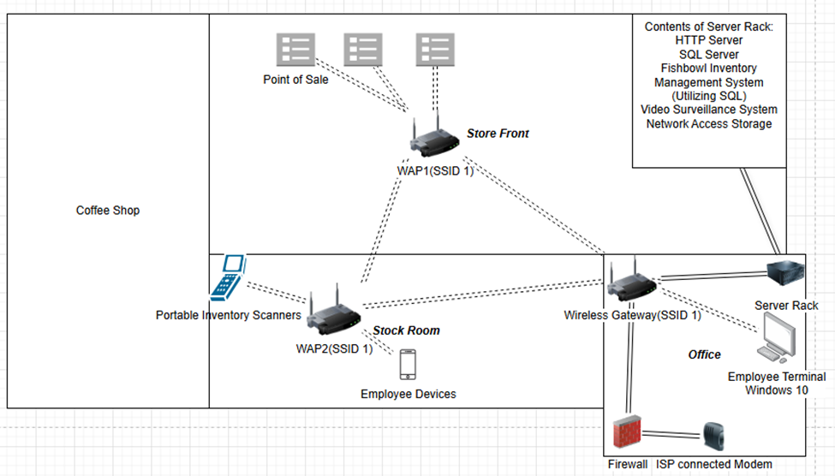
Summary: This is a diagram of the model store before implementing any improvements. The primary use of this diagram was as a reference for the design of the new network. Most of the network was connected via wi-fi, and network segmentation was non-existent, creating something often called a "flat network." Nothing in this diagram would have stopped an attack on the model store's insecure wi-fi, necessitating the transition over to a more security-conscious implementation.
Appendix B
Network Design Post Redesign
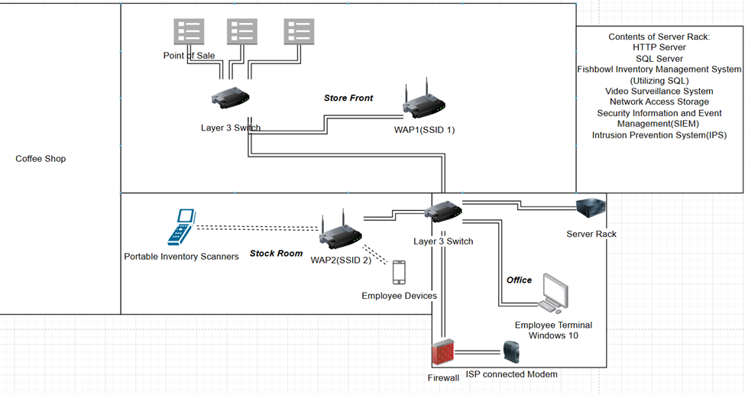
Summary: This is the network diagram for the model store after security concerns were considered. This diagram serves as evidence of work done by the MSP team and a reference for future changes to the network. Wi-fi usage has been cut down to portable inventory scanners, employee devices, and video cameras. The network is segmented via new WAP technologies and layer three switches, resulting in a more secure network and reduced payment card data environment. SEIM and IPS devices have been added to the server rack and are working together to gather and analyze logs.
Appendix C
Network Segmentation Table
VLAN Name | IP Range | Contents | Access Restrictions
Card Data Net | 192.168.100.0/24 | 3 Point of Sale Systems | Can communicate with Firewall
Stock Data Net | 192.168.90.0/24 | HTTP Server, SQL Server, Inventory Management Server, | Can communicate with Firewall for scheduled cloud backups every Friday night, receives communication from Scanner Net during work hours
Log Net | 192.168.80.0/24 | SIEM | Allows Syslog and SNMP traffic from all to Log Net  Allows logs to be sent to SIEM
Employee Net | 192.168.70.0/24 | Employee Personal Devices | Allows web connections outside of the company blocklist when connecting through the Firewall
Scanner Net | 192.168.60.0/24 | Scanners | Can Communicate with HTTP and Inventory Management System
Cam Net | 192.168.50.0/24 | Cameras, Video Surveillance System | Connects to Storage Net to store footage
Storage Net | 192.168.40.0/24 | Network Access Storage
Summary: This table is used to reference how the network for the model store has been segmented. Currently, the table is used as a reference for which segment new devices will be added to in the future in conjunction with Appendix B. It separates each section based on business function in a granular manner. Network segments that must communicate with each other to function are allowed to do so unless certain conditions are met. An example of this is the Stock Data Net to Scanner Net connection that allows for the transfer of scanner information only during work hours.

